Unit 2 – Lesson 4. Using Random in Android Apps
Aim:
How do we use random in Android apps?

Objectives: After the lesson, students will be able to:
- Design a simple Android app that displays an image at a random location.

CLASS PROCEDURE:

Do Now: In Java, how do we create random numbers? Write a Java method to return a pair of two random int x and y within (0, 300).

Presentation / Discussion:
- In Android, how do we generate a random number?

- In Android, how do we display a small image at a random position on the screen?

- In Android, say we stored 20 images in drawable, how do we randomly display one of the 20 images each time?

Pair – sharing Activity #1:
Did you go trick-or-treating on the day of Halloween this year? Let’s make a simple candy pick game.

- Create a new project in Android Studio and call it RandomApp.
- Define a TextView and an ImageButton on the activity_main.xml design.
- Find an image of candy online, make it really small and save it in png format. Add the image to the ImageButton.
- Add methods to MainActivity.java so that your app displays a piece of candy on the screen at a random location, and if the user clicks on the candy, then the TextView is updated and showing the number of candy “collected”.

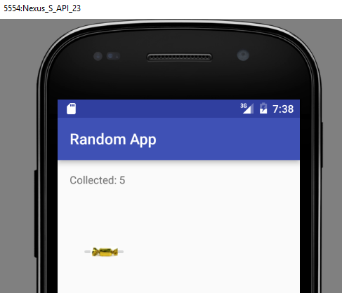

Pair – sharing Activity #2 / HW:

Continue working on the Whack – A – Mole app. Your app needs to have three screens, the first screen needs to display a picture and a start button, as well as a short description of game rules. The second screen should be the game screen. When the game ends, the 3rd screen should display the final score.

Sample Solution to Pair – sharing Activity #1:

MainActivity.java:
package com.example.wendyqiu.randomapp;

import android.graphics.Point;
import android.os.Bundle;
import android.support.v7.app.AppCompatActivity;
import android.view.*;
import android.widget.ImageButton;
import android.widget.TextView;
import java.util.Random;

public class MainActivity extends AppCompatActivity {

private int collected = 0;
private int screenWidth = 300;
private int screenHeight = 300;

@Override
protected void onCreate(Bundle savedInstanceState) {
super.onCreate(savedInstanceState);
setContentView(R.layout.activity_main);

Display display = getWindowManager().getDefaultDisplay();
Point size = new Point();
display.getSize(size);
screenWidth = size.x;
screenHeight = size.y;

TextView collectedView = (TextView) findViewById(R.id.collectedTV);
collectedView.setText("Collected: " + collected);

}

@Override
public boolean onCreateOptionsMenu(Menu menu) {
// Inflate the menu; this adds items to the action bar if it is present.
getMenuInflater().inflate(R.menu.menu, menu);
return true;
}

@Override
public boolean onOptionsItemSelected(MenuItem item) {
int id = item.getItemId();
return super.onOptionsItemSelected(item);
}

public void toRandomPosition(View view) {

collected += 1;
TextView collectedView = (TextView) findViewById(R.id.collectedTV);
collectedView.setText("Collected: " + collected);

Random random = new Random();

float candyX = (float) random.nextInt(screenWidth - 60);
float candyY = (float) random.nextInt(screenHeight - 60);

ImageButton imgButton = (ImageButton) findViewById(R.id.changePlace);
imgButton.setX(candyX);
imgButton.setY(candyY);
}
}

activity_main.xml

<?xml version="1.0" encoding="utf-8"?>
<LinearLayout xmlns:android="http://schemas.android.com/apk/res/android"
xmlns:tools="http://schemas.android.com/tools"
android:layout_width="match_parent"
android:layout_height="match_parent"
android:paddingLeft="@dimen/activity_horizontal_margin"
android:paddingRight="@dimen/activity_horizontal_margin"
android:paddingTop="@dimen/activity_vertical_margin"
android:paddingBottom="@dimen/activity_vertical_margin"
tools:context=".MainActivity"
android:weightSum="1">

<TextView android:id="@+id/collectedTV"
android:layout_width="wrap_content"
android:layout_height="wrap_content"/>

<ImageButton android:id="@+id/changePlace"
android:onClick="toRandomPosition"
android:contentDescription="I am random!"
android:layout_width="wrap_content"
android:layout_height="15dp"
android:adjustViewBounds="false"
android:src="@drawable/candy" />

</LinearLayout>

